# ABSTRACT

Job portal website was developed for creating an interactive job vacancy form for candidates. This web application managing updates both from the job seekers as well as the. It’s unique development methodology helps in acquiring the client and candidate information and separating them according to the job requirements and vacancies in online access to it provides details of the job. An employer being registered in the web site has the facility to use the services. Being an authorized users he can publish vacancy details and can search no of employees on portal and also he can search candidates on basis of the key skill which employee provides on registration. Explore job opportunities with our enhanced portal! Select your skills, choose the job type, and pick nearby locations for a personalized job search experience. Find the perfect match for your career effortlessly. Start your journey towards a fulfilling jobs Companies

**Keywords:** Online job search portal, Location and Skills preference, Customizable searches.

6

# ABBREVIATIONS

HTML – Hypertext Markup Language.

CSS – Cascading Style Sheet.

JS – Javascript.

PHP – Hypertext preprocessor.

# TABLE OF CONTENTS

Title Page No

|  |  |
| --- | --- |
| Abstract  Abbreviations | 1  2 |
| Introduction | 4 |
| Website Development Process | 5 |
| Implementation Procedure  System Requirements  Flow Diagram  Use Case Diagram  Class Diagram  ER Diagram | 7  8  10  11  12  13 |
| Architecture Diagram | 17 |
| Source Code | 24 |
| Conclusion | 51 |
| Future Enhancements  References | 52  53 |

**CHAPTER 1**

**1.INTRODUCTION**

The online job search portal website in purpose of designing the online job portal is to give the job seekers a platform for finding a right and a satisfactory job according to their qualification. It also connects the job seekers with the major companies. Job Portal will allow job provider to establish one to one relationship with candidates. This Portal will primarily focus on the posting and management of job vacancies. This system is designed such that ultimately all vacancies will be posted online and would offer employers the facilities to post their vacancies online. It helps to review and manage the resulting applications efficiently through the web

The System has three different actors (Admin, Company, Seeker).

Admin module contains 5 pages.

Company module contains 4 pages.

Job Serker module contains 5 pages.

|  |  |
| --- | --- |
| **ACTORS** | **DESCRIPTION** |
| Admin | Admin can add, edit, and delete the users. View all details |
| Company | To post a jobs and view the applicants. |
| Job Seeker | To enter the location or skills and get jobs.  The jobs are showed in table format the seeker can apply. |

**CHAPTER 2**

**2. WEBSITE DEVELOPMENT PROCESS**

**Analysis:** Firstly, better understand the website requirement creation, including website Design and Website looks and feels, the Web pages uses, website content and for suggestion and discussions, a proper space available on a web site for easily approachable.

**Design & Development:** Invention and Development is a significant role plays in Web Development. The Interface looks and feel according to most impressive and efficient way, Graphical elements required for design are appearing more impressive, for this use color and image.

**Content Writing:** Writing of contents is a significant part of development of web pages and plays an important and necessary step in optimization Engine, a well- defined or easy content is utterly necessary to fall in internet site users. Content written by a more professional requires more pure, easy and accurate content.

**Testing & Security:** Testing as well play an important role in website development, testing is done for browser compatibility, broken links and can check the speed of loading pages and loading speed of images. We can also check validation of HTML code, validation of CSS, checking of spelling and build alterations to rectification of mistakes and can perform test of functional on processes of websites like Booking, Order menu, Signup, Login, Admin side, etc., these checks as per requirement.

**Actual Implementation**

In our project we created an Online Job portal system. This is the project which keeps records of the employer, jobseeker, and administrator. The online Job portal system has three modules i.e. Jobseeker, Employer and Admin. which having the complete information of items and the job portal table. This Website shows the exact interior table view of the jobs and companies. We have used platform HTML, CSS, JS for frontend and PHP, MYSQL for backend in our job search portal.

There are 5 modules in our project:

* First module is home module. In this section, candidates can view job which is posted by an employer and apply for those jobs.
* Second module is Job portal overview.
* Third module is company and seeker register.

* Fourth module is usage of both company and seekers. • Fifth module is location preference
* Sixth module is feedback.

**2.1 Implementation Procedure:**

"In our project 'Online Job Search Portal,' the website encompasses all the modules and comprehensive information related to job searching. The website has been developed with a focus on feasibility, functionality, and user experience. The data and modules are organized for easy access, providing users with a seamless navigation experience. We have utilized HTML and CSS for the frontend, while PHP technology powers the backend, enabling dynamic content and interaction.

**There are three Actors (Admin, company seekers)**

**1. Admin module contains six pages**:

**View company:** view all company details.

**Seeker register:** view all seeker registered details.

**Company register:** view all company registered details.

**Feedback:** view all feedbacks.

**2.Company module contains three pages:**

**Company register:** Enter all company details.

**View or post job:** view company details and post a jobs.

**Feedback:** Enter the feedbacks.

**3.seeker register contains four pages.**

**Seeker register:** Enter all seeker personal and education details.

**Enter location or skills:** enter the location are skills to get the relevant jobs.

**Apply:** Apply the suitable jobs.

**Feedback:** Enter the feedbacks**.**

**CHAPTER 3**

**SYSTEM REQUIREMENTS**

HARDWARE REQUIREMENTS

Processor: Intel or above

Storage: Minimum 4GB or above

RAM: Minimum 4GB or above

Operating System: Minimum Windows 7 or above

SOFTWARE REQUIREMENTS

IDE: Visual Studio code 2015

Languages: HTML, CSS

Client-side script language: Java script

Server-side script language: PHP

**FLOW DIAGRAM USECASE DIAGRAM**

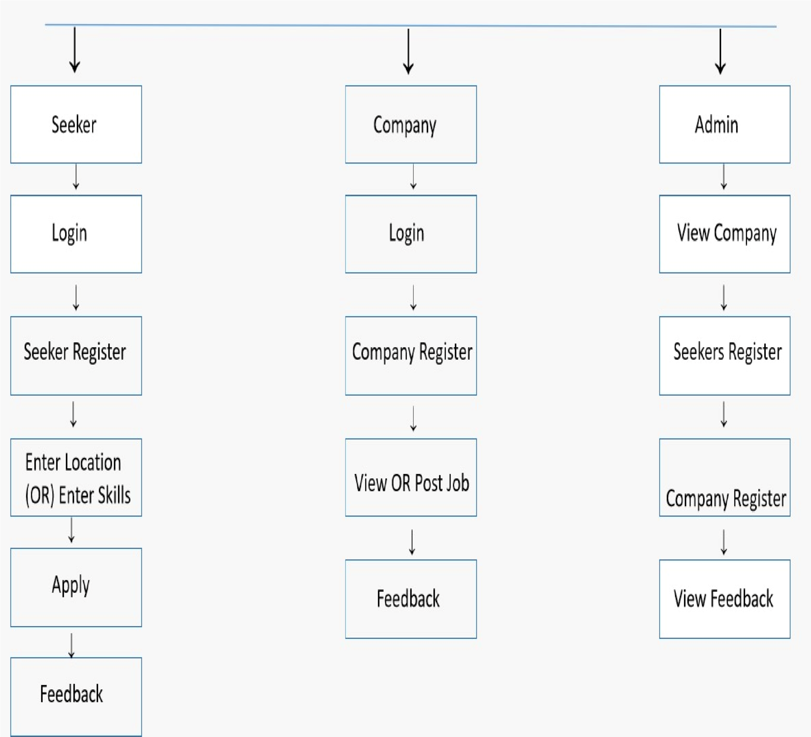

**JOB PORTAL**

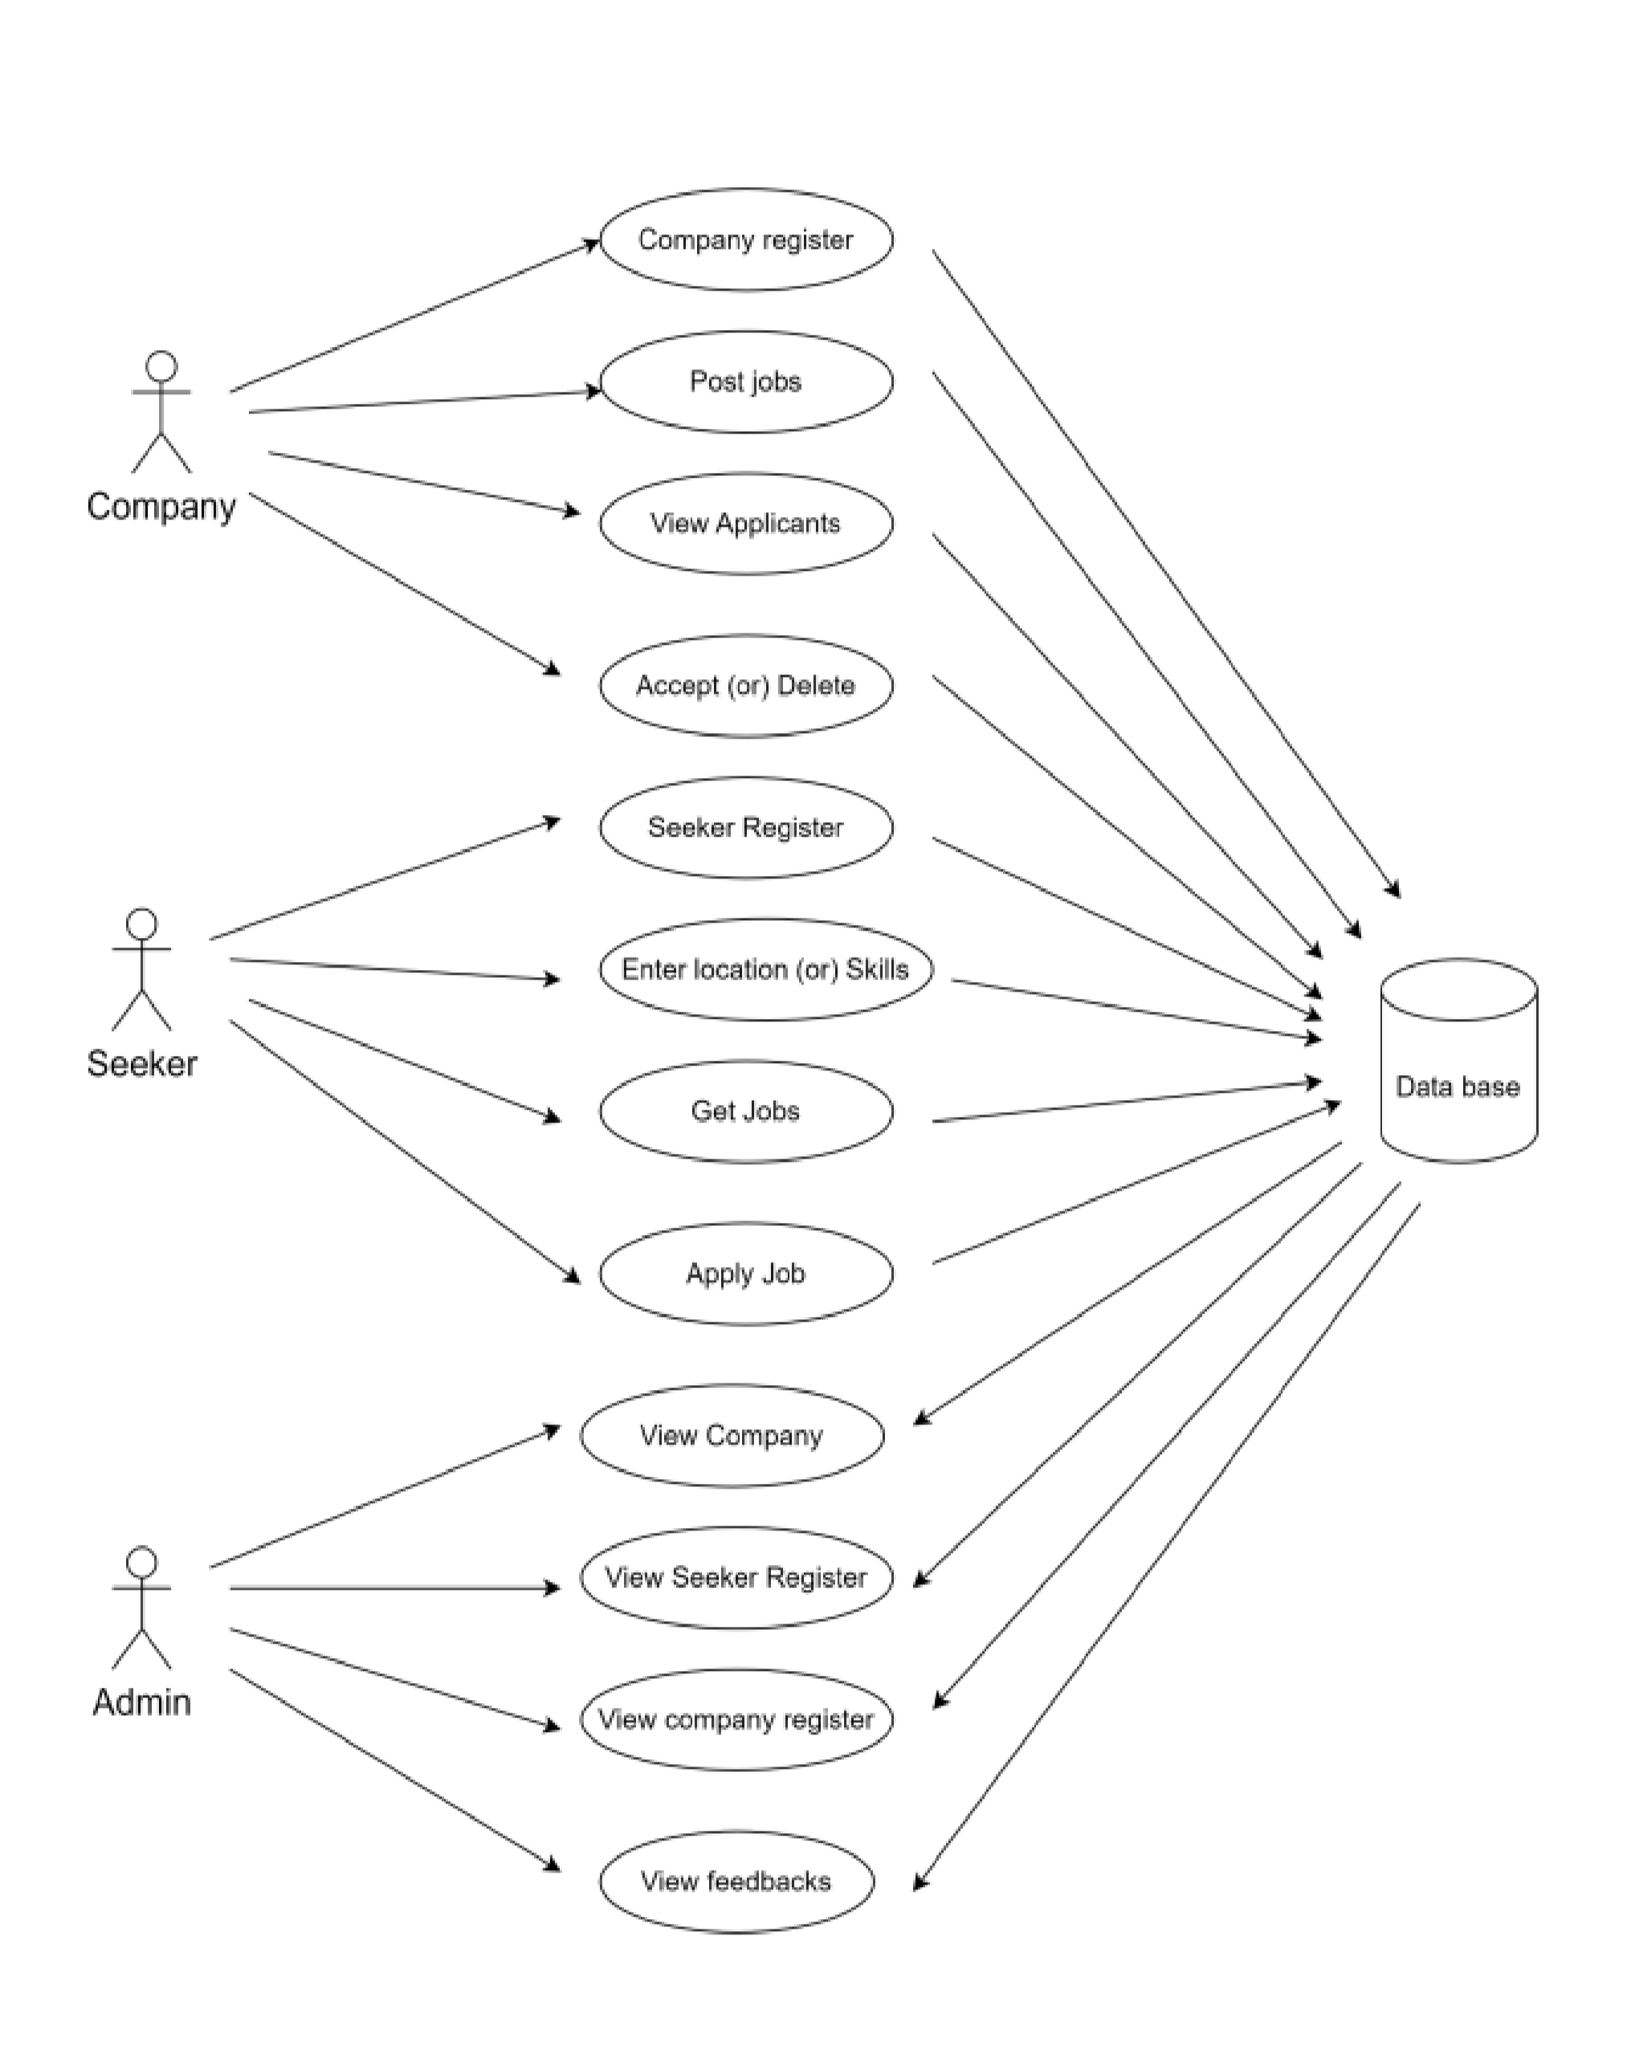

**CLASS DIAGRAM**

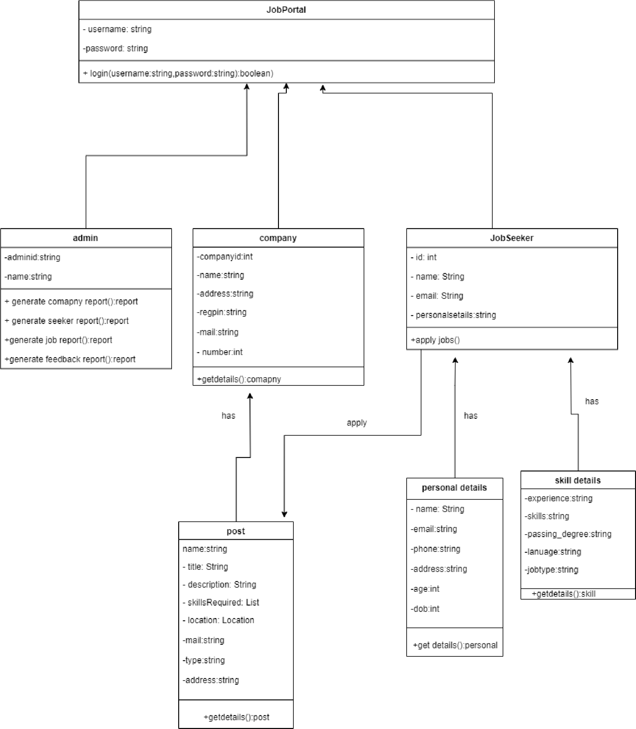

# ER DIAGRAM

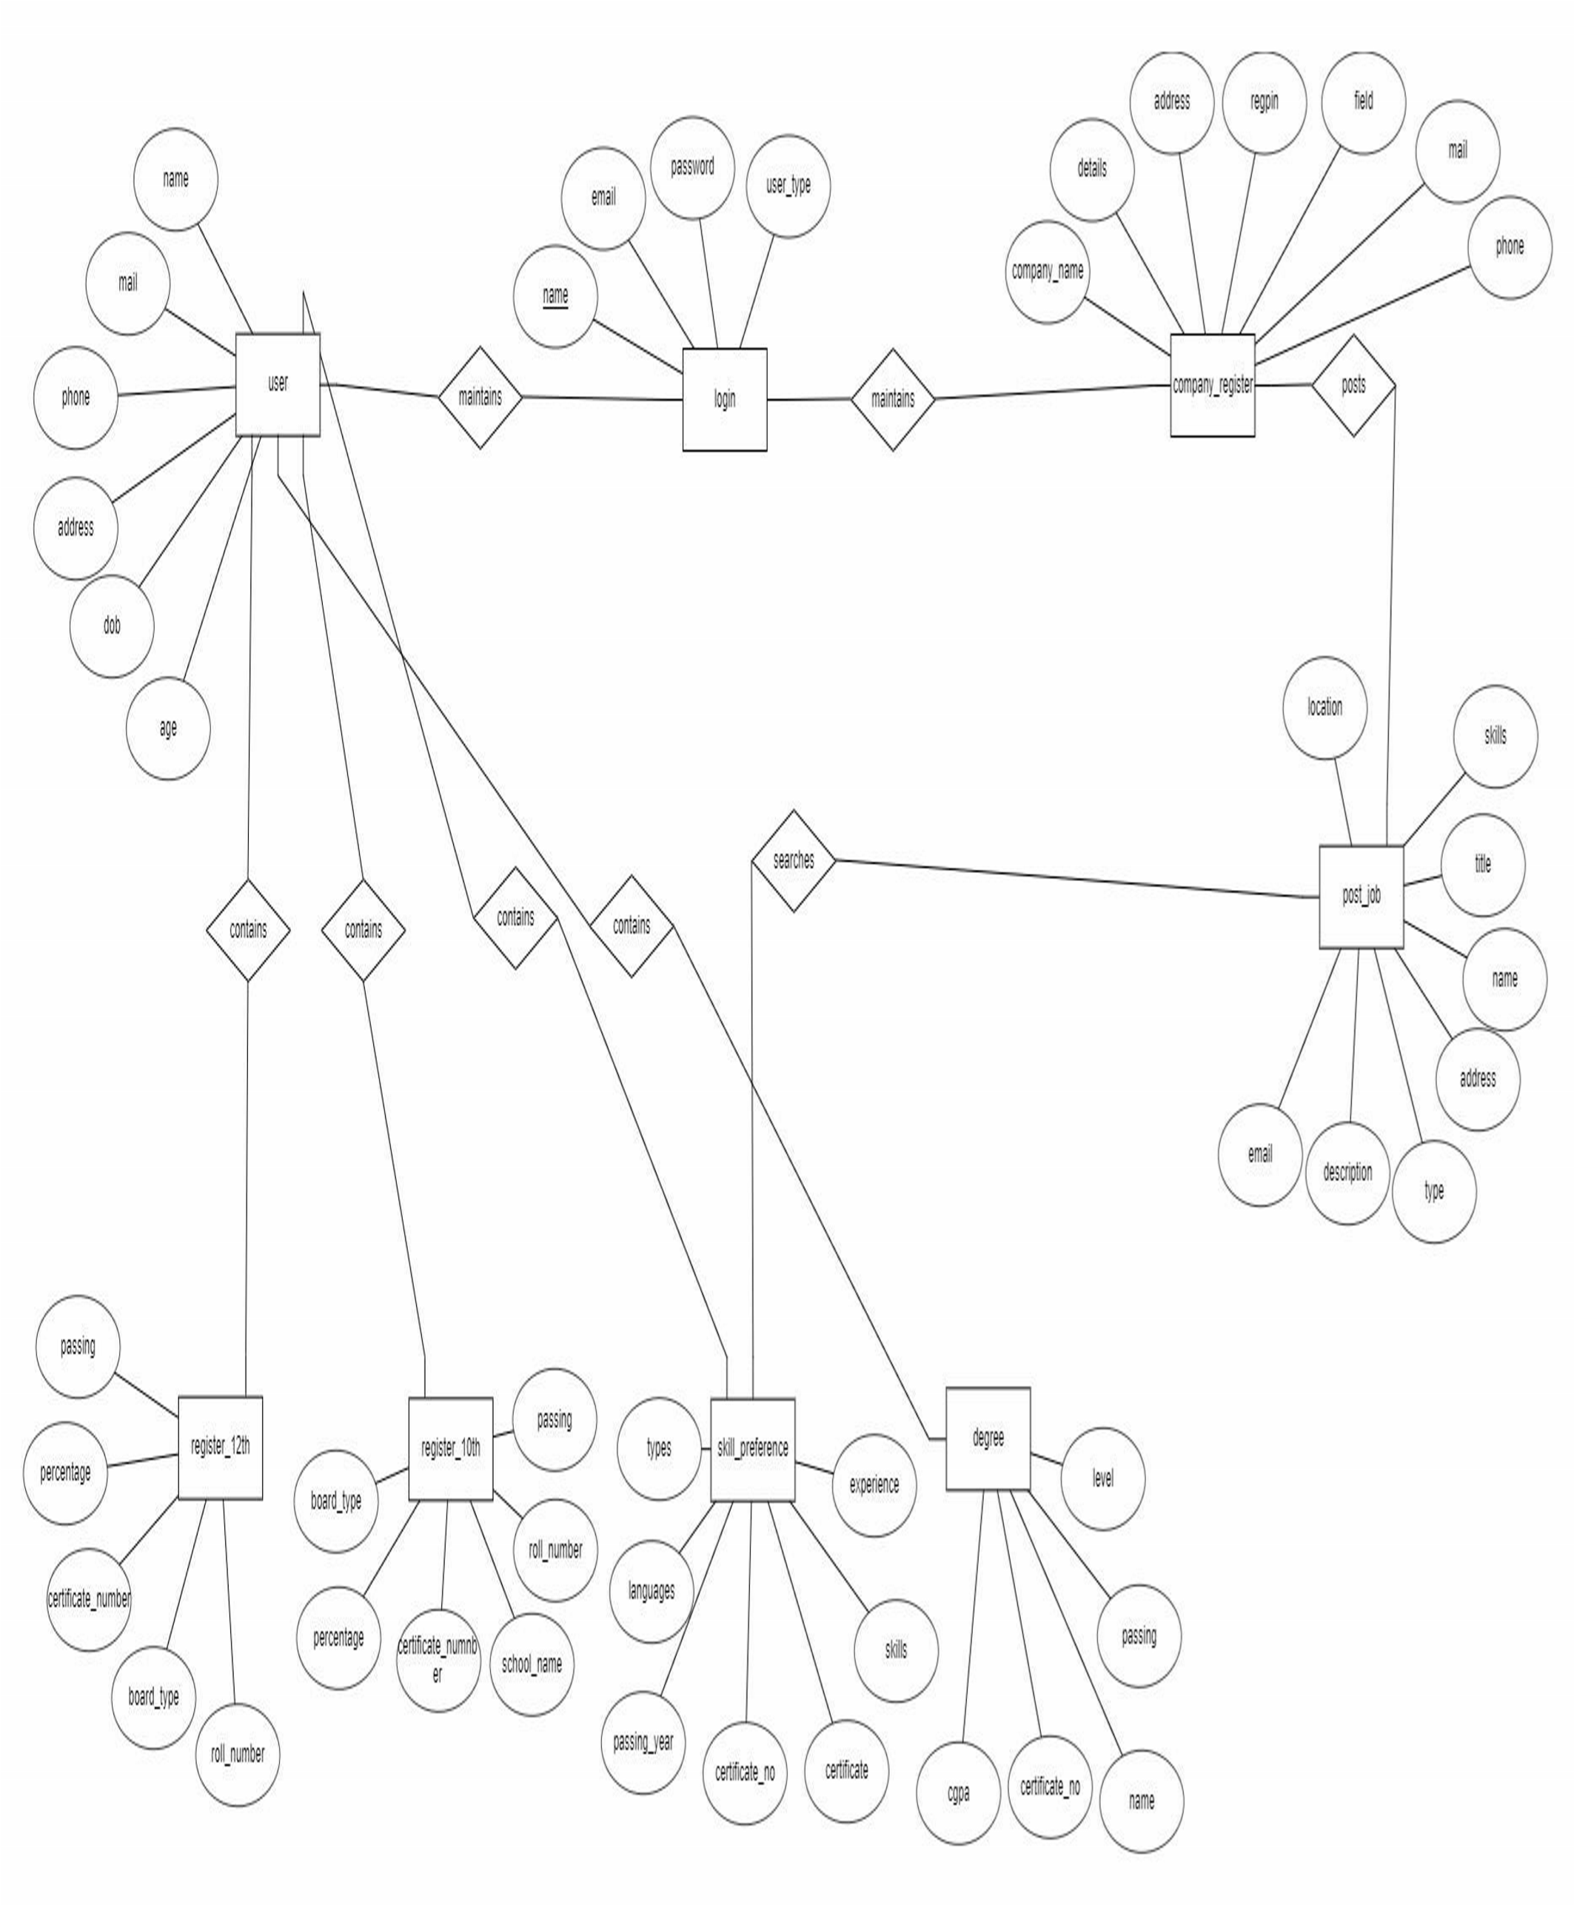

**ARCHITECTURE DAIGRAM** 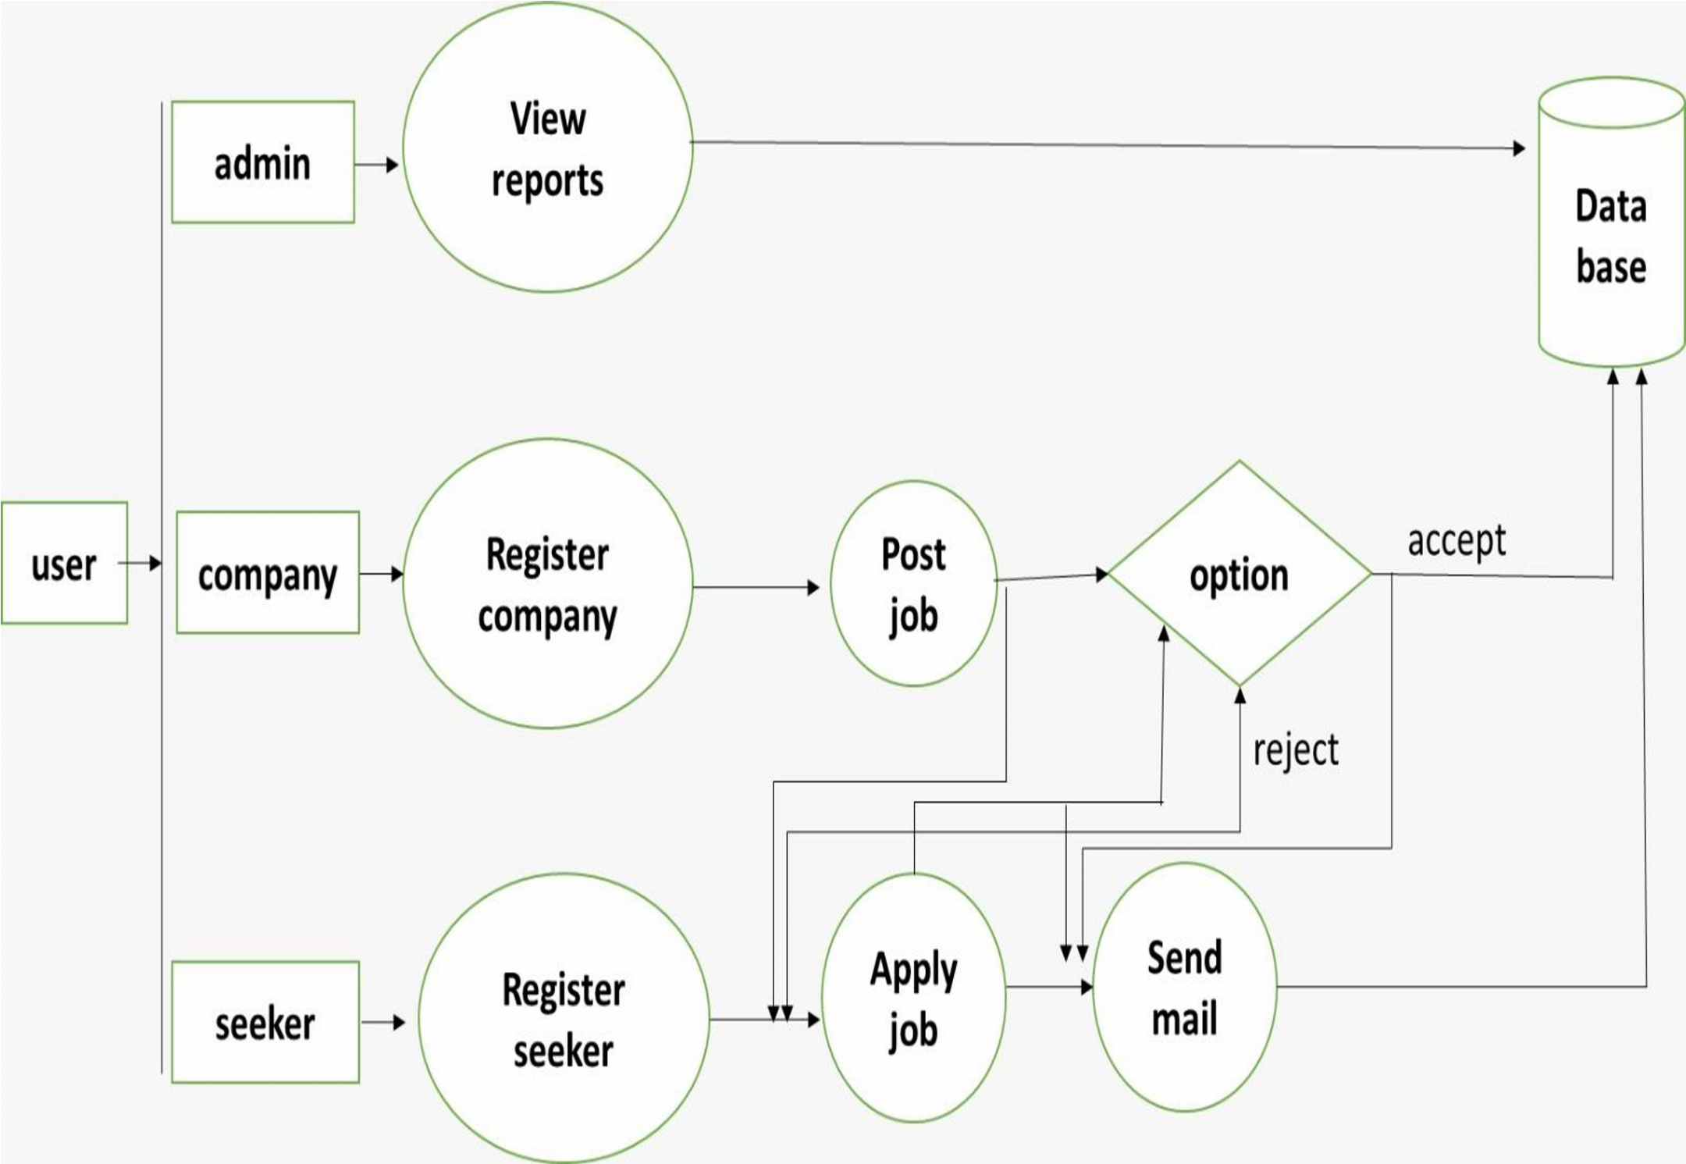

# CHAPTER 4

**RESULT AND DISCUSSION**

**LOGIN PAGE:**

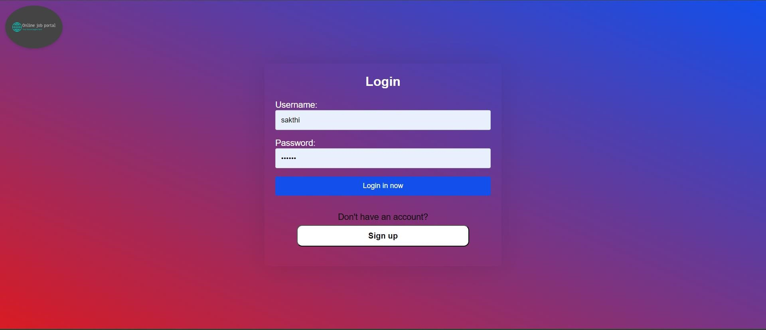

# SIGN UP:

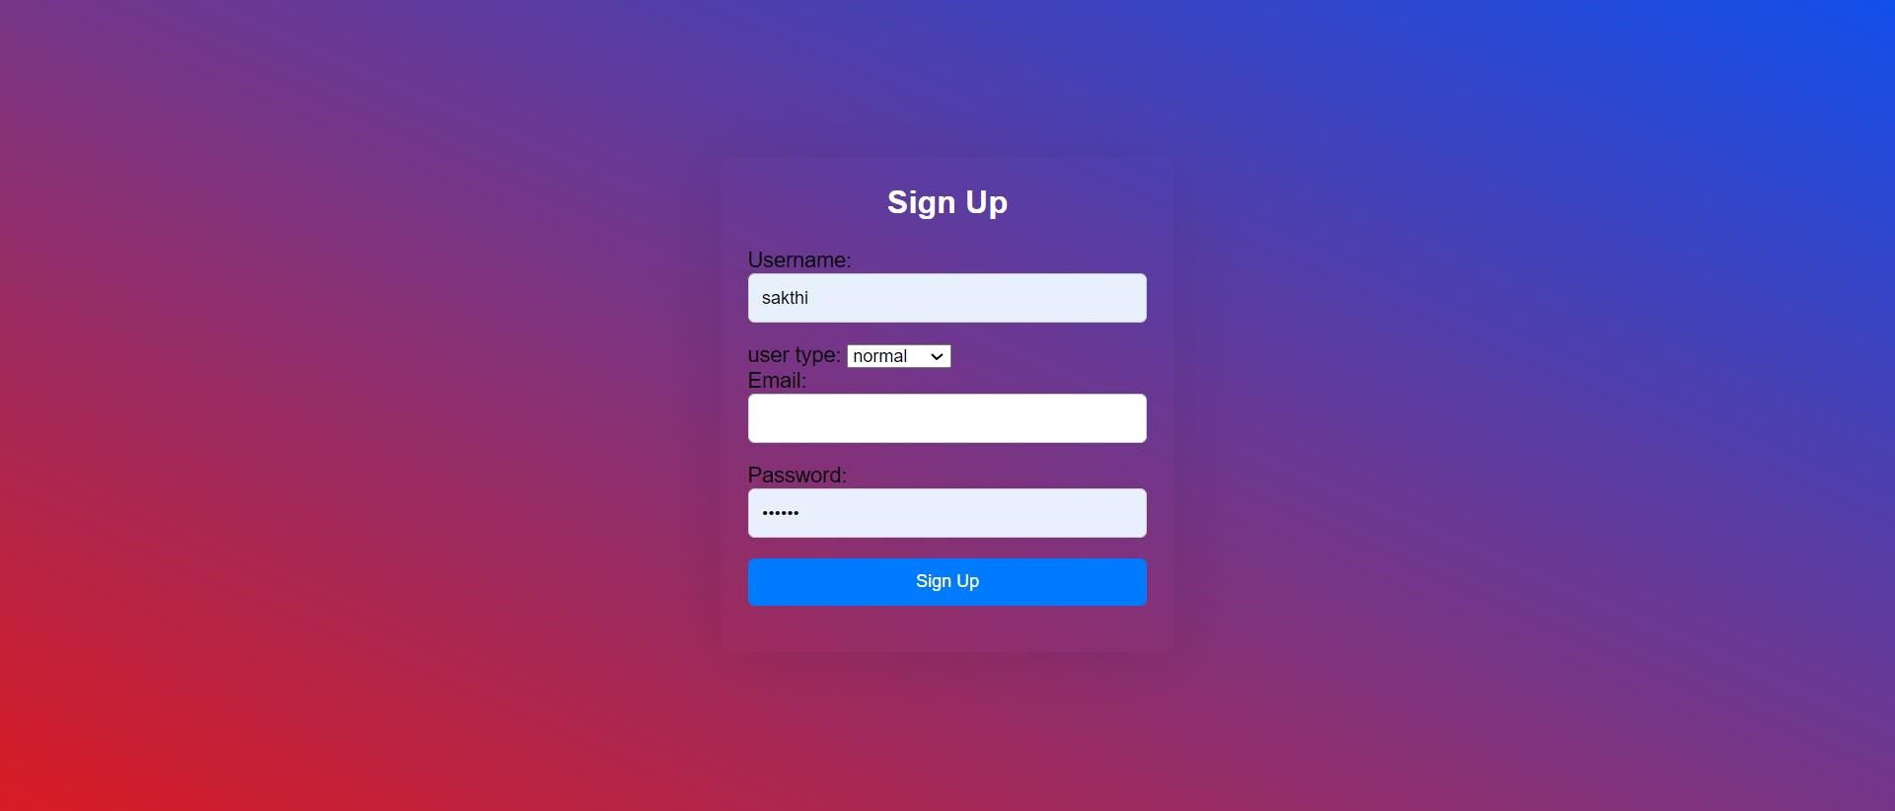

# HOME PAGE:

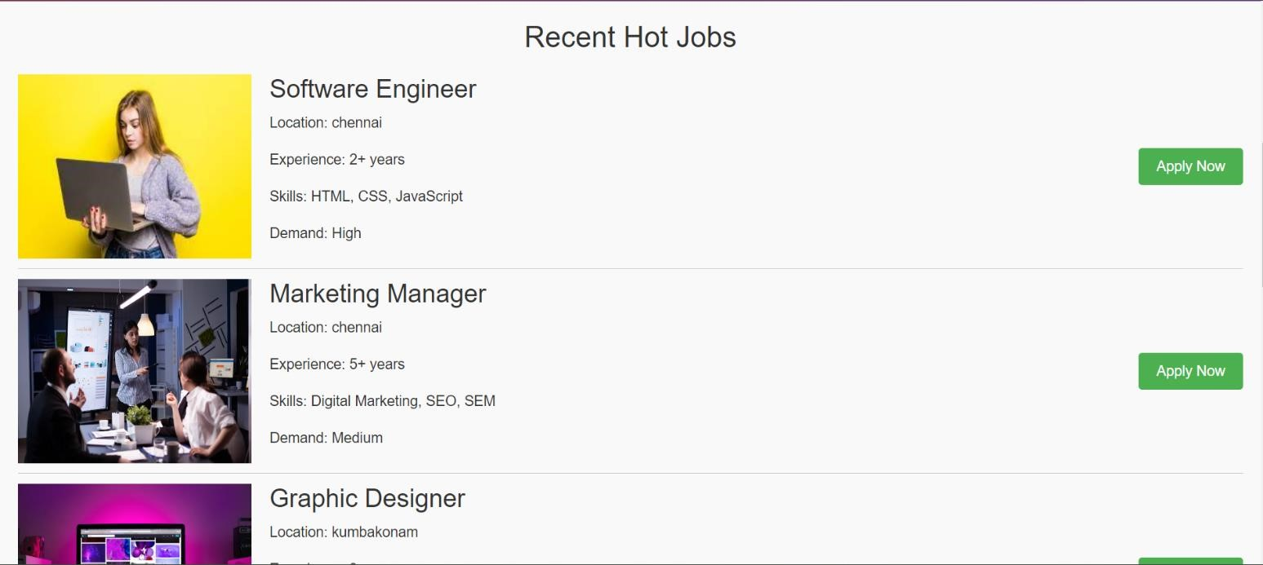

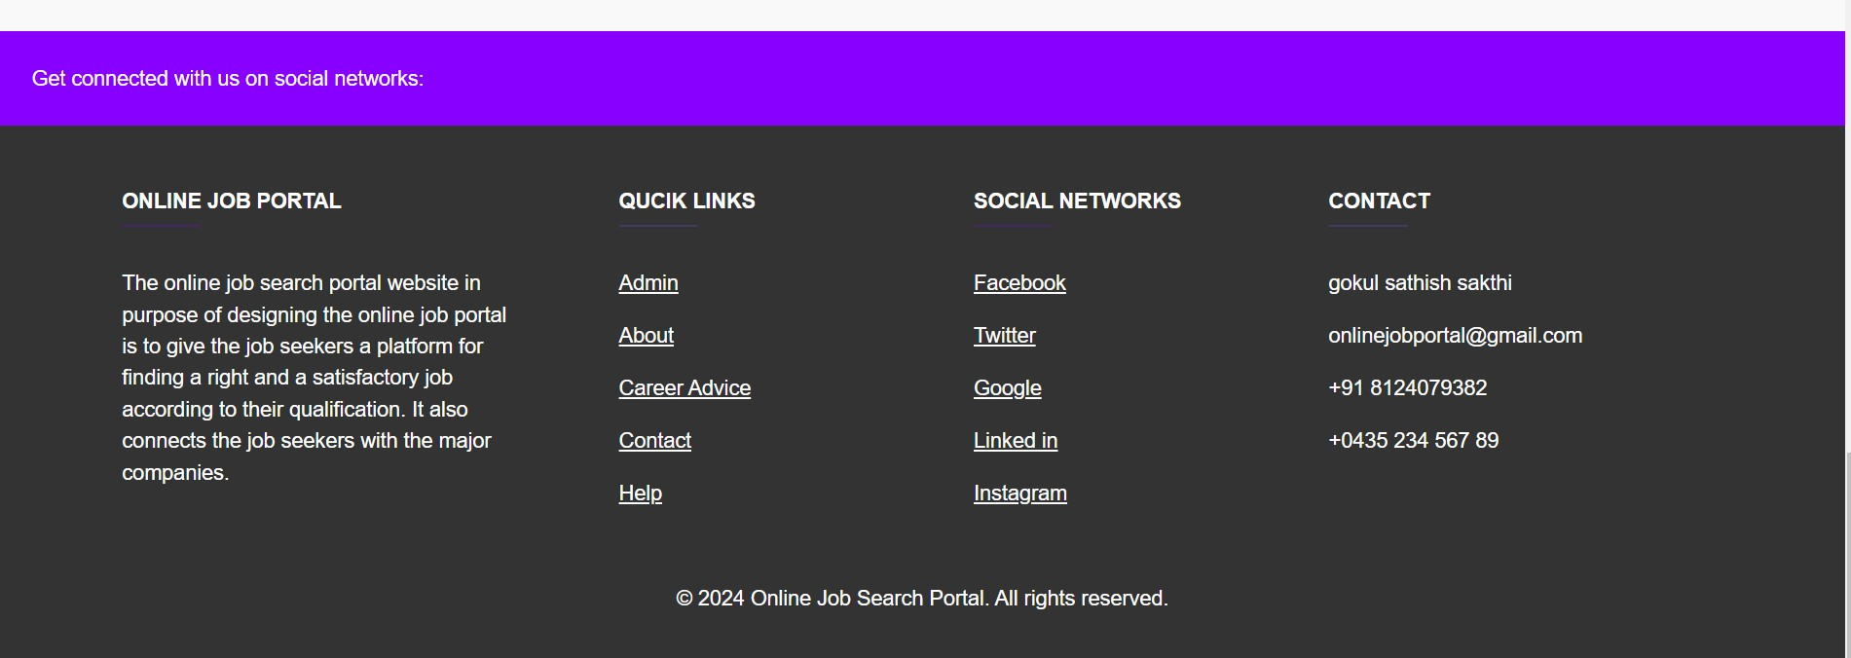

# ADMIN PAGE

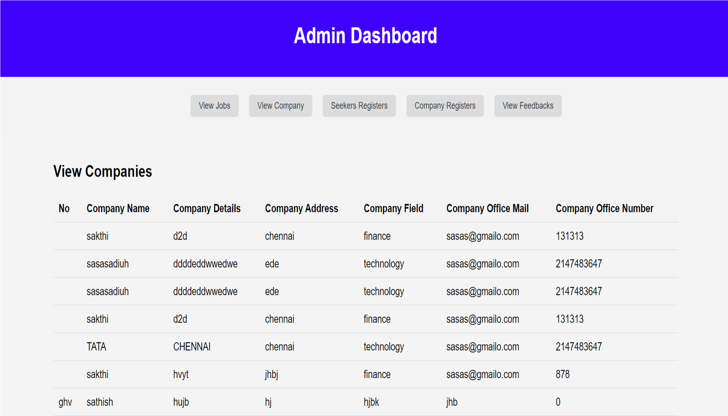

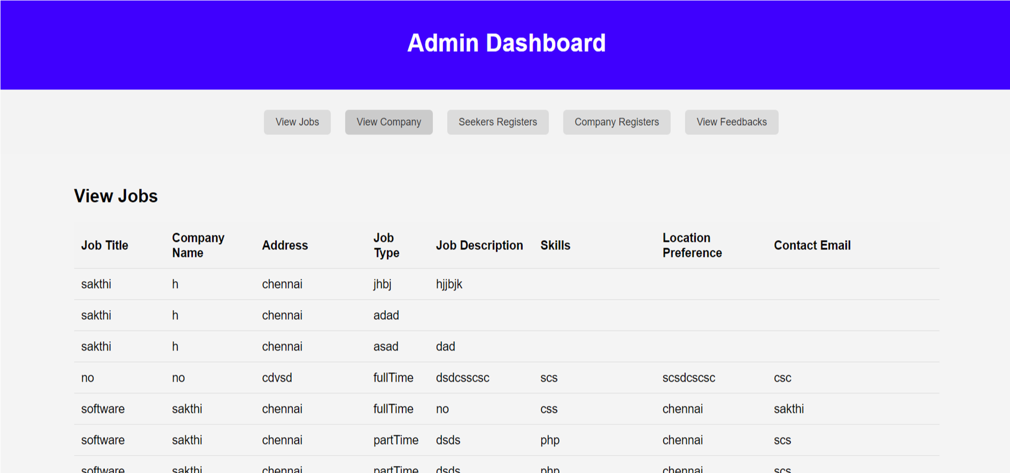

# SEEKER REGISTER PAGE

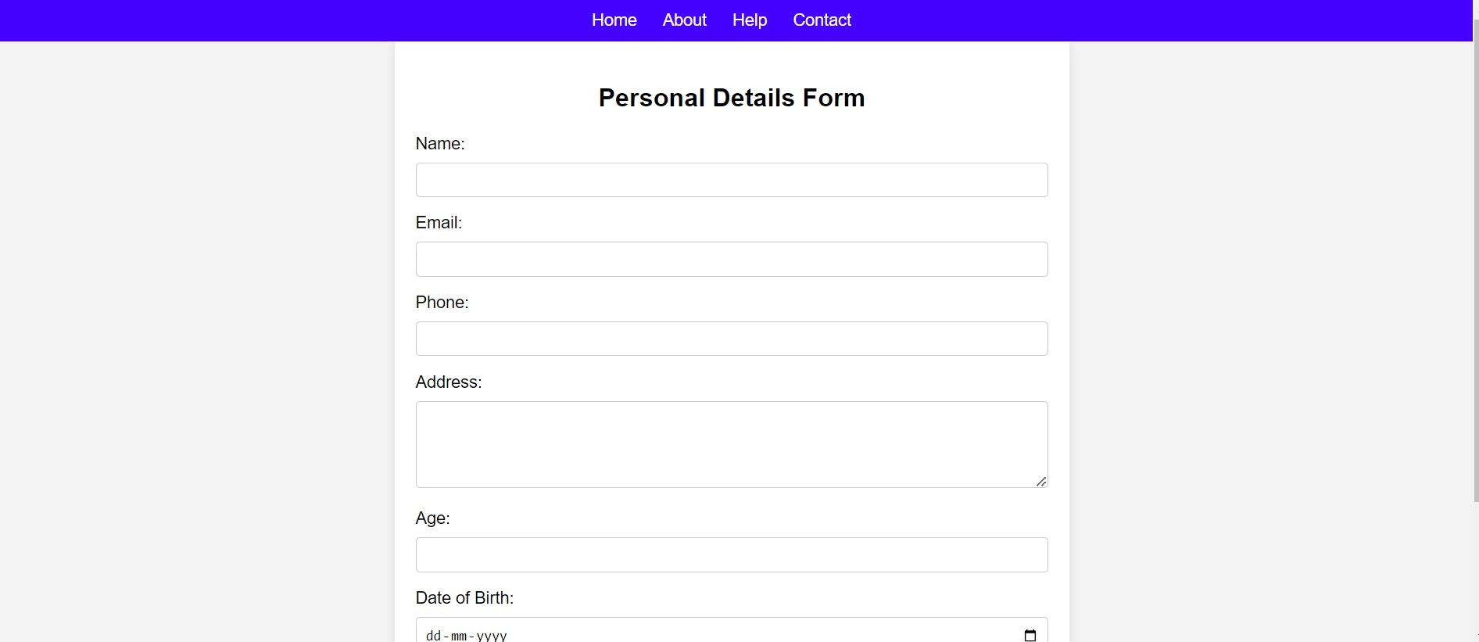

# COMPANY REGISTER PAGE

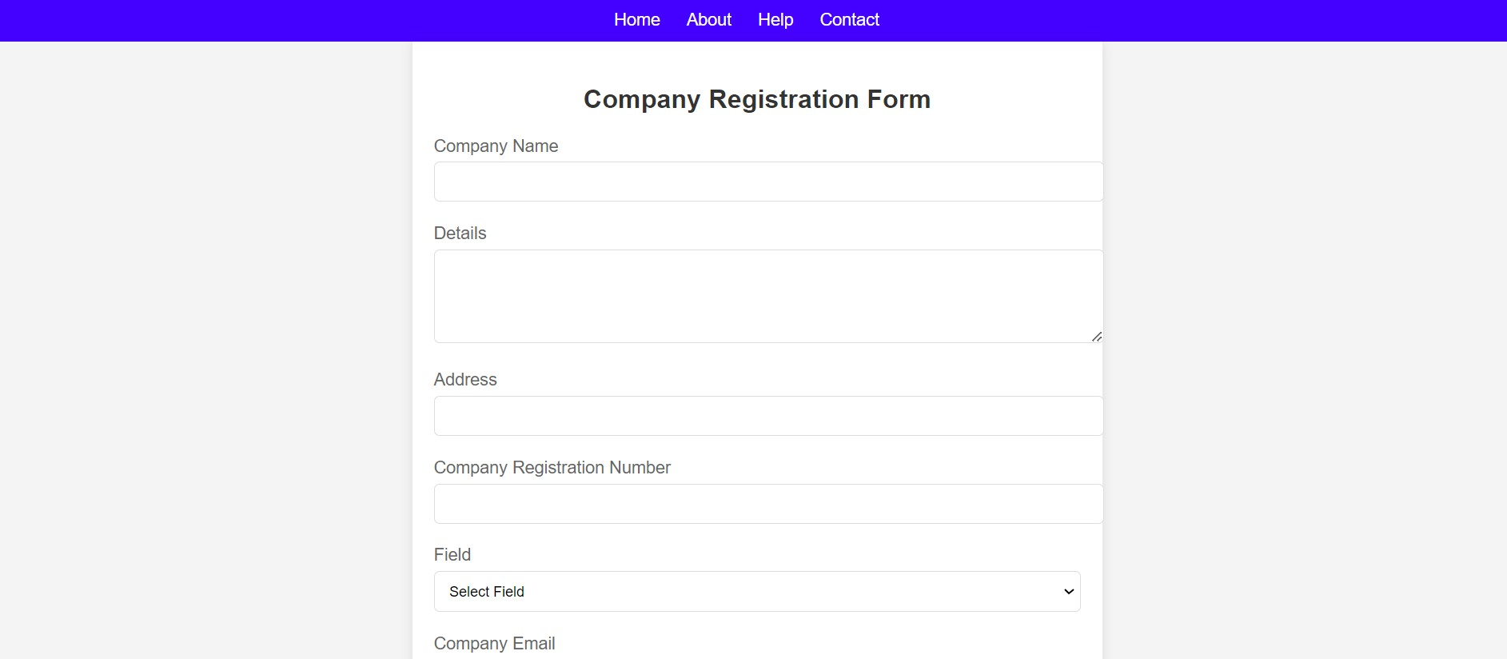

# LOCATION PREFERENCE

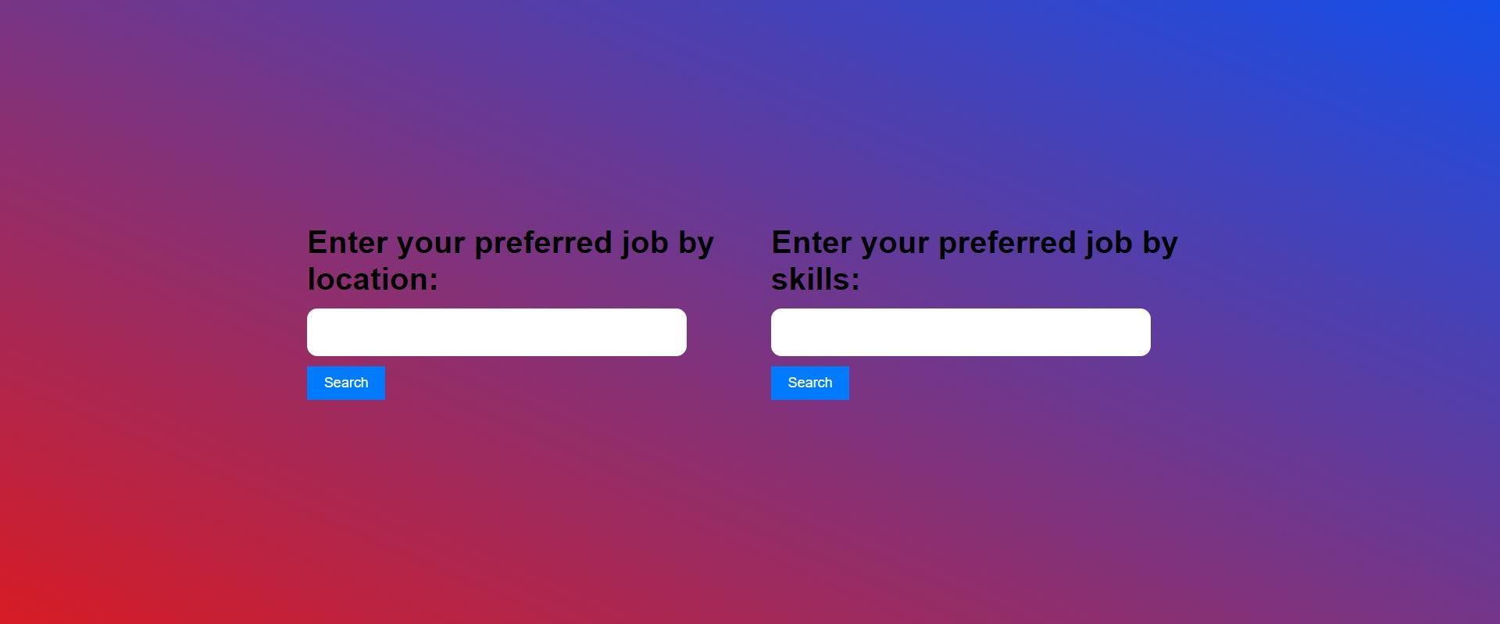

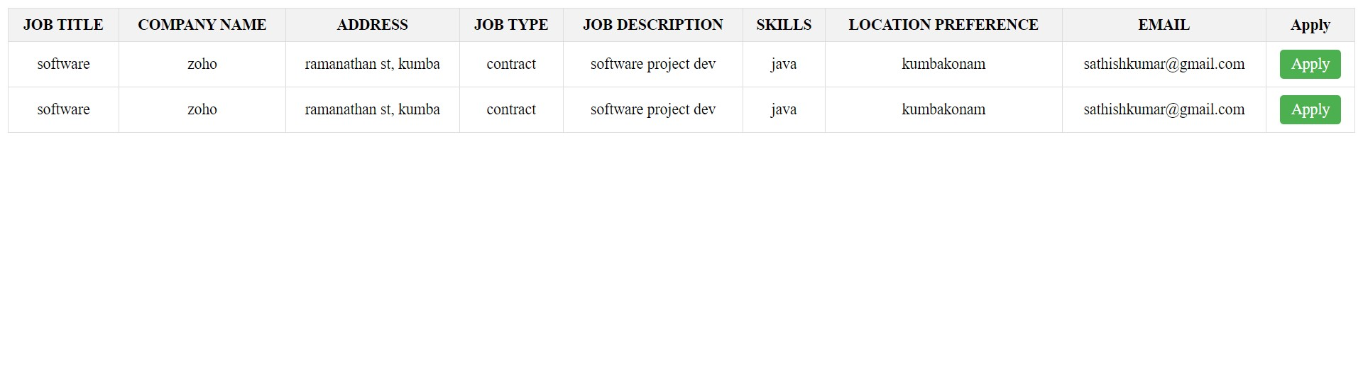

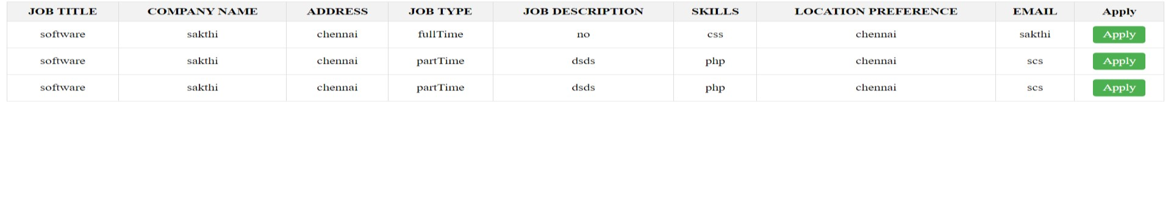

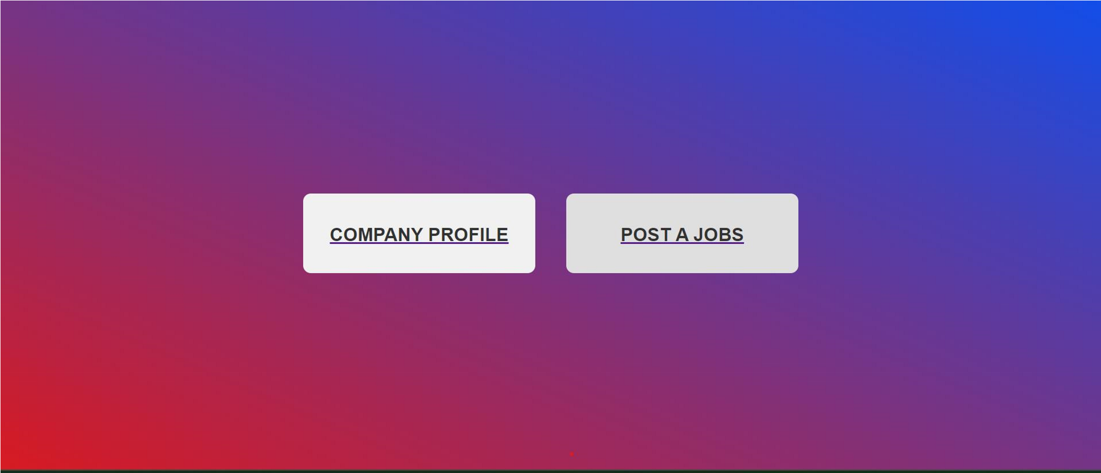

# COMPANY PROFILE

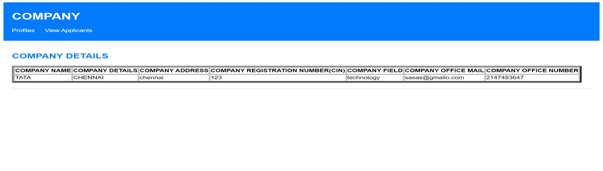

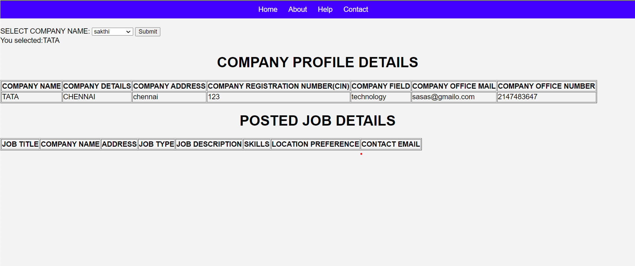

# POST A JOBS

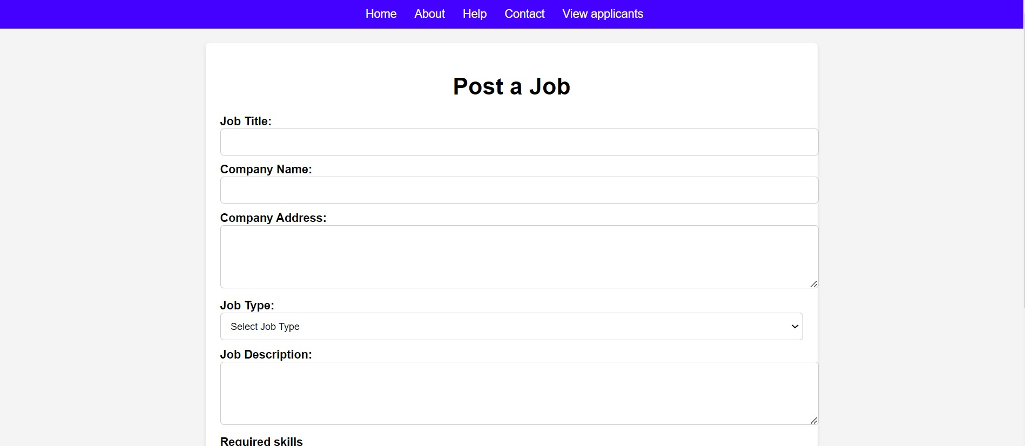

# FEEDBACK PAGE

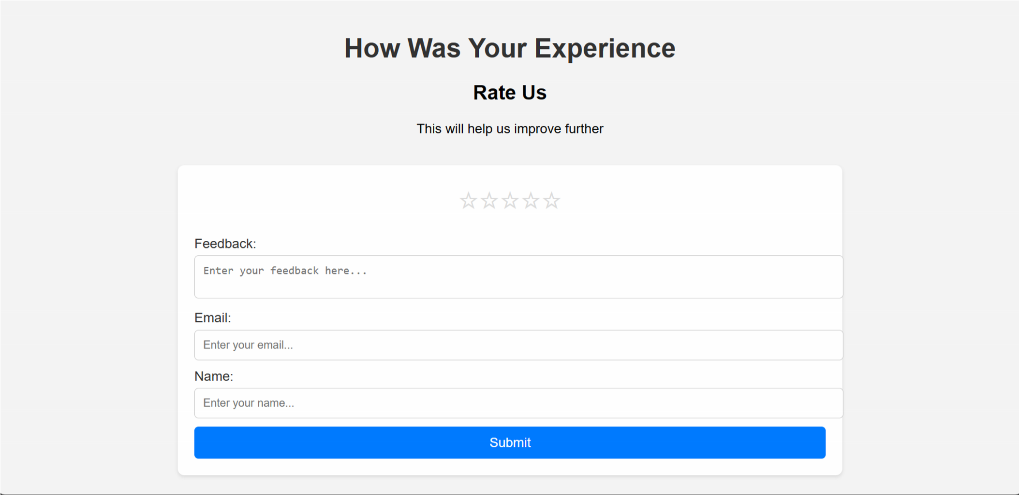

# CONTACT US PAGE

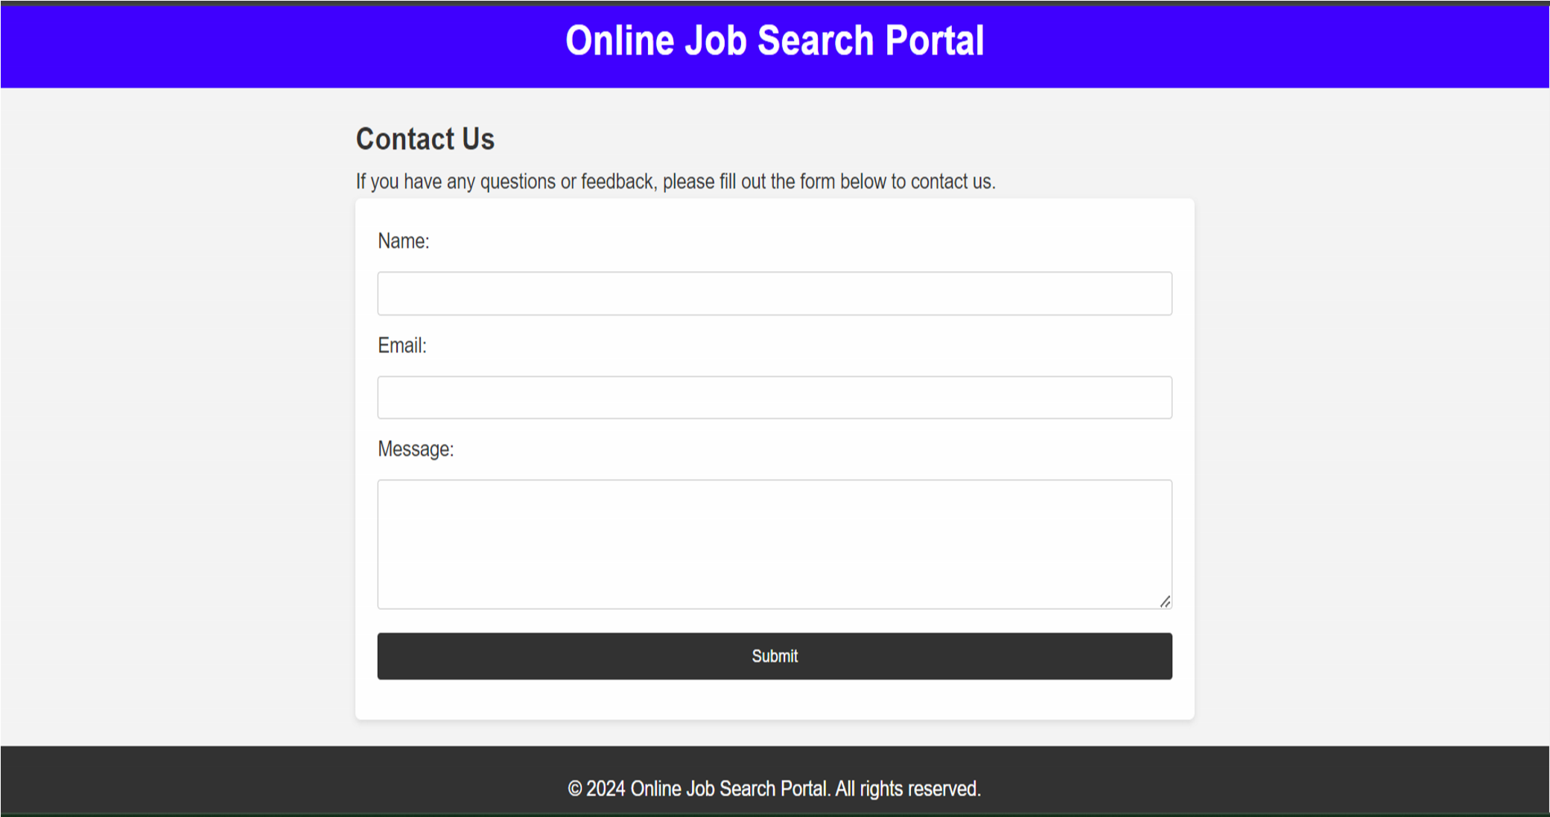

# CHAPTER 5

# SOURCE CODE

# LOGIN

**Login.php**

"<?php session_start();

?>

<!DOCTYPE html>

<html>

<head>

<title>Login Form</title>

<style> body {

font-family: Arial, sans-serif;

background-image: linear-gradient(to right top, #D91B23,

#124FEB);

background-color: #f4f4f4;

margin: 0; padding: 0; display: flex; justify-content: center; align-items: center; height: 100vh; position: relative;

} header { background: #333; color:

padding: 10px 0; text-align: center

}

.line {

position: absolute;

top: 0;

right: 0; width: 100%; height: 2px;

background-color:linear-gradient(to right top, #D91B23, #124FEB);

}

.login-container {

background-color: linear-gradient(to right top, #D91B23, #124FEB); padding: 20px; border-radius: 5px;

box-shadow: 0 2px 50px rgba(0, 0, 0, 0.1); max-width: 400px; margin: 0 auto;

hover

}

.login-container h2 { margin-top: 0; margin-bottom: 20px; text-align: center; color:white;

}

.login-container input[type="text"],

.login-container input[type="password"], .login-container input[type="submit"] {

width: 100%; padding: 10px; margin-bottom: 15px; box-sizing: border-box; border: 1px solid #ccc;

border-radius: 3px;

}

.login-container input[type="submit"] { background-color: #124FEB;

color: white; border: none; cursor: pointer;

}

.login-container input[type="submit"]:hover {

background-color: linear-gradient(to right top, #D91B23, #124FEB);

}

.logo {

position: absolute; top: 10px; left: 10px; height: 80px; border-radius: 50%;

box-shadow: 0 2px 5px rgba(0, 0, 0, 0.1);

}

form::before {

content: ''; position: absolute;

top: 0; left: -100%; width: 100%; height: 100%;

background-color: rgba(255, 255, 255, 0.1);

transition: left 0.3s ease;

}

form:hover::after {

left: 0;

}

button{ margin-top: 5px; width: 80%; background-color: #ffffff; color: #080710; padding: 10px 0; font-size: 15px; font-weight: 600; border-radius: 10px; cursor: pointer;

}

</style>

</head>

<body>

<header>

</header>

<div class="line"></div>

<img src="uploads/1.jpg" alt="Logo" class="logo">

<div class="login-container">

<h2>Login</h2>

<form action="#" method="post">

<label style="color:white"for="username">Username:</label> <input type="text" id="username" name="username">

<label style="color:white" for="password">Password:</label>

<input type="password" id="password" name="password"> <br>

<input type="submit" name="submit" value="Login in now"> </form>

<p style="text-align: center;">Don't have an account? <a href="signup.php"><button> Sign up</button></a></p>

</div>

</body>

</html>

<?php

require 'uploads/dbconnect.php';

if(isset($_POST['submit'])) {

$sql = "SELECT * FROM `personal` WHERE

name='".$_POST['username']."' AND password='".$_POST['password']."'";

$result = mysqli_query($db_connection, $sql); if(mysqli_num_rows($result)>0) {

$_SESSION['user'] = $_POST['username']; $row= mysqli_fetch_array($result); if($row['user_type'] == 'normal') {

?>

<script>

window.location = 'home.html';

</script>

<?php

} elseif($row['user_type'] == 'seeker') {

?>

<script>

window.location = 'home.html';

</script>

<?php

} elseif($row['user_type'] == 'company') {

$sql2 = "SELECT * FROM `companyregister` WHERE

`name`='".$_POST['username']."'";

$result2 = mysqli_query();

?>

<script>

window.location = 'home.html';

</script>

<?php

} else {

?>

<script>

window.location = 'admin.php'; </script>

<?php

}

} else {

?>

<script>

alert("Username or password is invalid");

</script>

<?php

}

}

?>

</body>

</html>

**SIGN UP**

**Signup.php**

<!DOCTYPE html>

<html>

<head>

<title>Sign Up</title>

<style> body {

font-family: Arial, sans-serif;

background-image: linear-gradient(to right top, #D91B23, #124FEB); background-color: #f4f4f4;

margin: 0; padding: 0; display: flex; justify-content: center; align-items: center; height: 100vh; position: relative;

} header { background: #333; color: #fff; padding: 10px 0; text-align: center;

}

.signup-container {

background-color: linear-gradient(to right top, #D91B23, #124FEB); padding: 20px; border-radius: 5px;

box-shadow: 0 5px 50px rgba(0, 0, 0, 0.1); width: 300px;

}

.signup-container h2 { margin-top: 0; margin-bottom: 20px; text-align: center; color:white;

}

.signup-container input[type="text"],

.signup-container input[type="email"],

.signup-container input[type="password"], .signup-container input[type="submit"] { width: 100%;

padding: 10px; margin-bottom: 15px; box-sizing: border-box; border: 1px solid #ccc;

border-radius: 5px;

}

.signup-container input[type="submit"] { background-color: #007bff;

color: #fff; border: none; cursor: pointer;

}

.signup-container input[type="submit"]:hover { background-color: #0056b3;

}

</style>

</head>

<body>

<header>

</header>

<div class="signup-container">

<h2>Sign Up</h2>

<form action="#" method="post">

<label for="Name">Username:</label>

<input type="text" id="Name" name="Name">

<label for="user">user type:</label>

<select name="user" id="user">

<option value="normal">normal</option>

<option value="seeker">seeker</option>

<option value="company">company</option>

</select><br>

<label for="email">Email:</label>

<input type="email" id="email" name="email">

<label for="password">Password:</label>

<input type="password" id="password" name="password">

<input type="submit" name="submit" value="Sign Up" >

</form>

</div> <?php

require 'uploads/dbconnect.php';

if(isset($_POST['submit'])){

$db_connection = mysqli_connect("localhost","root","","job portal");

$name = mysqli_real_escape_string($db_connection, $_POST['Name']);

$email = mysqli_real_escape_string($db_connection, $_POST['email']);

$ps = mysqli_real_escape_string($db_connection, $_POST['password']);

$user = mysqli_real_escape_string($db_connection, $_POST['user']);

$sql = "INSERT INTO `personal`(`Name`, `email`, `password`,`user_type`) VALUES ('$name','$email','$ps','$user')";

$result = mysqli_query($db_connection,$sql);

if($result) { ?> <script> alert("Successfully registered"); window.location = 'login.php';

</script> <?php exit(); } else {

echo "Error: " . mysqli_error($db_connection);

}

mysqli_stmt_close($stmt);

mysqli_close($db_connection);

}

?>

</body>

</html>

# HOME.HTML

home.html

<!DOCTYPE html>

<html lang="en">

<head>

<meta charset="UTF-8">

<meta name="viewport" content="width=device-width, initial-scale=1.0">

<title>Home page</title> <link rel="stylesheet"

href="https://cdn.jsdelivr.net/npm/bootstrap@5.3.0/dist/css/bootstrap.min.css">

<link

href="https://cdn.jsdelivr.net/npm/bootstrap@5.0.2/dist/css/bootstrap.min.css" rel="stylesheet" integrity="sha384-

EVSTQN3/azprG1Anm3QDgpJLIm9Nao0Yz1ztcQTwFspd3yD65VohhpuuCO mLASjC" crossorigin="anonymous">

<script

src="https://cdn.jsdelivr.net/npm/bootstrap@5.0.2/dist/js/bootstrap.bundle.min.js

" integrity="sha384-

MrcW6ZMFYlzcLA8Nl+NtUVF0sA7MsXsP1UyJoMp4YLEuNSfAP+JcXn/tWt

IaxVXM" crossorigin="anonymous"></script>

<script

src="https://cdn.jsdelivr.net/npm/@popperjs/core@2.9.2/dist/umd/popper.min.js" integrity="sha384-

IQsoLXl5PILFhosVNubq5LC7Qb9DXgDA9i+tQ8Zj3iwWAwPtgFTxbJ8NT4G

N1R8p" crossorigin="anonymous"></script>

<script

src="https://cdn.jsdelivr.net/npm/bootstrap@5.0.2/dist/js/bootstrap.min.js" integrity="sha384-

cVKIPhGWiC2Al4u+LWgxfKTRIcfu0JTxR+EQDz/bgldoEyl4H0zUF0QKbrJ0

EcQF" crossorigin="anonymous"></script>

<style> body {

font-family: Arial, sans-serif;

background-image: linear-gradient(to right top, #D91B23, hsl(259, 100%,

74%));

background-color: #f4f4f4;

color: #333; margin: 0; padding: 0; }

.navbar { background-color:#4000ff;

padding: 10px 0;

}

.navbar-brand, .navbar-nav .nav-link { color: #fff;

}

@keyframes slide { 0% { left: 0; }

100% {

left: calc(100% - 100px);

}

}

.photo-container { position: relative; overflow: hidden; padding-top: 56.25%;

margin-top: 20px;

}

.photo-container img { position: absolute; top: 0;

left: 0; width: 100%; height: 100%; object-fit: cover;

transition: opacity 0.5s;

}

.job-listings { background-color: #f9f9f9; padding: 20px; margin: 10px 0 0 0;

}

.job-listings h2 { margin-bottom: 10px;

}

.job-listings ul { padding: 0;

}

.job-listings li { border-bottom: 1px solid #ccc; padding: 10px 0; display: flex;

align-items: center;

}

.job-listings li img { margin-right: 20px; max-width: 260px; height: 200px;

}

.job-listings li div { flex: 1;

}

.apply-button { background-color: #4CAF50;

color: #fff; padding: 8px 20px; border: none; border-radius: 4px; cursor: pointer;

text-decoration: none;

}

footer { background-color: #333; color: #fff; text-align: center; padding: 20px 0; padding-top: 0; margin: 0; width: 100%;

}

.footer .container { display: flex; flex-wrap: wrap;

justify-content: center;

}

.footer .col-md-6 {

margin-bottom: 20px;

}

.footer ul { padding: 0; list-style: none;

}

.footer ul li {

margin-bottom: 10px;

}

.footer p {

margin-bottom: 10px;

}

.footer hr {

border-top: 1px solid #fff; margin: 20px 0;

}

@media only screen and (max-width: 800px) {

.bsc_a li { display: flex;

flex-direction: column;

}

}

</style>

</head>

<body style="background-color: linear-gradient(to right top, #D91B23,

#124FEB);;">

<nav class="navbar navbar-expand-lg navbar-dark justify-content-center">

<div style="padding: 0;" class="container">

<a class="navbar-brand ms-0 me-auto" href="#">ONLINE JOB

SEARCH PORTAL</a>

<button class="navbar-toggler" type="button" data-bs-toggle="collapse" data-bs-target="#navbarNav" aria-controls="navbarNav" aria-expanded="false" aria-label="Toggle navigation">

<span class="navbar-toggler-icon"></span>

</button>

<div class="collapse navbar-collapse justify-content-end" id="navbarNav">

<ul class="navbar-nav">

<li class="nav-item">

<a class="nav-link active" aria-current="page" href="#">Home</a>

</li>

<li class="nav-item">

<a class="nav-link" href="about.html">About</a>

</li>

<li class="nav-item dropdown">

<a class="nav-link dropdown-toggle" href="#" id="navbarDropdown1" role="button" data-bs-toggle="dropdown" ariaexpanded="false">

Jobs

</a>

<ul class="dropdown-menu" arialabelledby="navbarDropdown1">

<li><a class="dropdown-item" href="jobs1.html">Popular categories</a></li>

<li><a class="dropdown-item" href="jobs3.html">Jobs in demand</a></li>

</ul>

</li>

<li class="nav-item dropdown">

<a class="nav-link dropdown-toggle" href="#" id="navbarDropdown2" role="button" data-bs-toggle="dropdown" ariaexpanded="false">

Company

</a>

<ul class="dropdown-menu" arialabelledby="navbarDropdown2">

<li><a class="dropdown-item" href="it.html">IT

Company</a></li>

<li><a class="dropdown-item" href="nonit.html">NON IT

Company</a></li>

<li><a class="dropdown-item"

href="industrial.html">Industrial Company</a></li>

</ul>

</li>

<li class="nav-item">

<a class="nav-link" href="career.html">Career Advice</a>

</li>

<li class="nav-item dropdown">

<a class="nav-link dropdown-toggle" href="#" id="navbarDropdown2" role="button" data-bs-toggle="dropdown" ariaexpanded="false">

Register

</a>

<ul class="dropdown-menu" arialabelledby="navbarDropdown2">

<li><a class="dropdown-item" href="per.php">Seeker

Register</a></li>

<li><a class="dropdown-item"

href="companyregister.php">Company Register</a></li>

<li><a class="dropdown-item" href="login1.php">Already seeker Registered</a></li>

<li><a class="dropdown-item" href="login2.php">Already company Rigistered</a></li>

</ul>

</li>

<li class="nav-item">

<a class="nav-link" href="contact.html">Contact us</a>

</li>

<li class="nav-item">

<a class="nav-link" href="login.php">Log out</a>

</li>

</ul>

</div>

</div>

</nav>

<br>

<center>

<video width="720" controls>

<source src="uploads/video.mp4" type="video/mp4"> <source src="mov_bbb.ogg" type="video/ogg"> Your browser does not support HTML video. </video></center>

<hr>

<div class="job-listings">

<h2 style="text-align: center;">Recent Hot Jobs</h2>

<ul class="bsc_a">

<li>

<img src="uploads/softwar.jpg" alt="Software Engineer">

<div>

<h3>Software Engineer</h3> <p>Location: chennai</p>

<p>Experience: 2+ years</p>

<p>Skills: HTML, CSS, JavaScript</p>

<p>Demand: High</p>

</div>

<a href="per.php"><button class="apply-button">Apply

Now</button></a>

</li> <li>

<img src="uploads/marketing.jpg" alt="Marketing Manager">

<div>

<h3>Marketing Manager</h3>

<p>Location: chennai</p>

<p>Experience: 5+ years</p>

<p>Skills: Digital Marketing, SEO, SEM</p>

<p>Demand: Medium</p>

</div>

<a href="per.php"><button class="apply-button">Apply

Now</button></a>

</li> <li>

<img src="uploads/graphicdesign.jpg" alt="Graphic Designer">

<div>

<h3>Graphic Designer</h3>

<p>Location: kumbakonam</p>

<p>Experience: 3+ years</p>

<p>Skills: Adobe Photoshop, Illustrator</p>

<p>Demand: Medium</p>

</div>

<a href="#" class="apply-button">Apply Now</a>

</li> <li>

<img src="uploads/dataanalyst.jpg" alt="Data Analyst">

<div>

<h3>Data Analyst</h3>

<p>Location: chennai</p>

<p>Experience: 3+ years</p>

<p>Skills: SQL, Python, Data Visualization</p>

<p>Demand: High</p>

</div>

<a href="per.php"><button class="apply-button">Apply

Now</button></a>

</li> <li>

<img src="uploads/webdeveloper.jpg" alt="Web Developer">

<div>

<h3>Web Developer</h3>

<p>Location: kovai</p>

<p>Experience: 3+ years</p>

<p>Skills: JavaScript, React.js, Node.js</p>

<p>Demand: High</p>

</div>

<a href="per.php"><button class="apply-button">Apply

Now</button></a>

</li>

</ul>

</div>

<div > <footer class="text-center text-lg-start text-white"

style="background-color: #333; margin: 0;"

>

<section class="d-flex justify-content-between p-4"

style="background-color: #8800ff;"

>

<div class="me-5">

<span>Get connected with us on social networks:</span> </div>

<div>

<a href="" class="text-white me-4">

<i class="fab fa-facebook-f"></i>

</a>

<a href="" class="text-white me-4">

<i class="fab fa-twitter"></i>

</a>

<a href="" class="text-white me-4">

<i class="fab fa-google"></i>

</a>

<a href="" class="text-white me-4">

<i class="fab fa-instagram"></i>

</a>

<a href="" class="text-white me-4">

<i class="fab fa-linkedin"></i>

</a>

<a href="" class="text-white me-4">

<i class="fab fa-github"></i>

</a>

</div>

</section>

<section class="">

<div class="container text-center text-md-start mt-5">

<div class="row mt-3">

<div class="col-md-3 col-lg-4 col-xl-3 mx-auto mb-4">

<h6 class="text-uppercase fw-bold"> Online Job Portal</h6>

<hr

class="mb-4 mt-0 d-inline-block mx-auto"

style="width: 60px; background-color:#8800ff;; height: 2px"

/>

<p>

The online job search portal website in purpose of designing the online job portal is to give the job seekers a platform for finding a right and a satisfactory job according to their qualification. It also connects the job seekers with the major companies.

</p>

</div>

<div class="col-md-3 col-lg-2 col-xl-2 mx-auto mb-4">

<h6 class="text-uppercase fw-bold">Qucik links</h6>

<hr

class="mb-4 mt-0 d-inline-block mx-auto"

style="width: 60px; background-color: #7c4dff; height: 2px"

/>

<p>

<a href="admin.php" class="text-white">Admin</a>

</p>

<p>

<a href="about.html" class="text-white">About</a>

</p> <p>

<a href="career.html" class="text-white">Career Advice</a>

</p>

<p>

<a href="contact.html" class="text-white">Contact</a>

</p>

<p>

<a href="help.html" class="text-white">Help</a>

</p>

</div>

<div class="col-md-2 col-lg-2 col-xl-2 mx-auto mb-4">

<h6 class="text-uppercase fw-bold">Social Networks</h6>

<hr

class="mb-4 mt-0 d-inline-block mx-auto"

style="width: 60px; background-color:#8800ff;height: 2px"

/>

<p>

<a

href="https://www.facebook.com/thala.sathish.1848816?mibextid=ZbWKwL" class="text-white">Facebook</a>

</p>

<p>

<a

href="https://x.com/d_naughty_boy03?t=8prJ4sKgjHbvHdUQKZwITw&s=09" class="text-white">Twitter</a>

</p> <p>

<a href=" https://www.google.com " class="text-white">Google</a>

</p>

<p>

<a

href="https://www.linkedin.com/help/linkedin/?trk=p_settings_helpcenter_global nav_android" class="text-white">Linked in</a>

</p>

<p>

<a

href="https://www.instagram.com/sathish.nck._?igsh=MXNzNHY5NmVzeGNp eg==" class="text-white">Instagram</a>

</p>

</div>

<div class="col-md-4 col-lg-3 col-xl-3 mx-auto mb-md-0 mb-4">

<h6 class="text-uppercase fw-bold">Contact</h6>

<hr

class="mb-4 mt-0 d-inline-block mx-auto"

style="width: 60px; background-color: #7c4dff; height: 2px"

/>

<p><i class="fas fa-home mr-3"></i> gokul sathish sakthi</p>

<p><i class="fas fa-envelope mr-3"></i>

onlinejobportal@gmail.com</p>

<p><i class="fas fa-phone mr-3"></i>+91 8124079382</p>

<p><i class="fas fa-print mr-3"></i> +0435 234 567 89</p>

</div>

</div>

</div>

</section>

<div

class="text-center p-3"

style="background-color: #333"

>

<p>&copy; 2024 Online Job Search Portal. All rights reserved.</p> </div>

</footer>

</div>

<script

src="https://cdn.jsdelivr.net/npm/bootstrap@5.3.0/dist/js/bootstrap.bundle.min.js "></script>

</body>

</html>

# SEEKER REGISTER

**per.php**

<!DOCTYPE html>

<html lang="en">

<head>

<meta charset="UTF-8">

<meta name="viewport" content="width=device-width, initial-scale=1.0"> <title>Personal Details Form</title>

<style> body { font-family: Arial, sans-serif; background-color: #f4f4f4;

margin: 0; padding: 0;

}

.container { max-width: 600px; margin: 0 auto; background: #fff; padding: 20px;

box-shadow: 0 0 10px rgba(0, 0, 0, 0.1);

} nav {

background-color: #4501ff;

color: #fff; padding: 10px 20px; text-align: center;

} nav ul {

list-style-type: none; margin: 0; padding: 0;

} nav ul li { display: inline-block;

margin-right: 20px;

}

nav ul li a { color: #fff;

text-decoration: none;

} h2 { text-align: center;

margin-bottom: 20px;

} label { display: block;

margin-bottom: 8px;

}

input[type="text"], input[type="email"], input[type="tel"], input[type="date"], input[type="file"], textarea { width: 100%; padding: 8px; margin-bottom: 15px; border: 1px solid #ccc; border-radius: 4px; box-sizing: border-box;

}

input[type="submit"] {

background-color: #4CAF50; color: white; padding: 10px 15px; border: none; border-radius: 4px; cursor: pointer;

width: 100%;

}

input[type="submit"]:hover {

background-color: #45a049;

}

</style>

</head>

<body>

<nav>

<ul>

<li><a href="home.html">Home</a></li>

<li><a href="about.html">About</a></li>

<li><a href="help.html">Help</a></li>

<li><a href="contact.html">Contact</a></li>

</ul>

</nav>

<div class="container">

<h2>Personal Details Form</h2>

<form action="#" enctype="multipart/form-data" method="post">

<label for="name">Name:</label>

<input type="text" id="name" name="name" required>

<label for="email">Email:</label>

<input type="email" id="email" name="email" required>

<label for="phone">Phone:</label>

<input type="tel" id="phone" name="phone" required>

<label for="address">Address:</label>

<textarea id="address" name="address" rows="4" required></textarea>

<label for="age">Age:</label>

<input type="text" id="age" name="age" required>

<label for="dob">Date of Birth:</label>

<input type="date" id="dob" name="dob" required>

<label for="resume">Resume:</label>

<input type="file" id="resume" name="resume" accept=".pdf,.doc,.docx" required>

<input type="submit" name="submit" value="Next">

</form> <?php require 'uploads/dbconnect.php'; if(isset($_POST['submit'])){

$db_connection = mysqli_connect("localhost","root","","job portal");

$name = mysqli_real_escape_string($db_connection, $_POST['name']);

$email = mysqli_real_escape_string($db_connection, $_POST['email']);

$phone = mysqli_real_escape_string($db_connection, $_POST['phone']);

$address = mysqli_real_escape_string($db_connection, $_POST['address']);

$age = mysqli_real_escape_string($db_connection, $_POST['age']);

$dob = mysqli_real_escape_string($db_connection, $_POST['dob']);

$resume = $_FILES['resume']['name'];

$resume_tmp = $_FILES['resume']['tmp_name'];

move_uploaded_file($resume_tmp, "uploads/".$resume);

$sql = "INSERT INTO `personal1`(`name`, `email`, `phone`, `address`,

`age`, `dob`) VALUES ('$name', '$email', '$phone', '$address', '$age', '$dob')"; $result = mysqli_query($db_connection, $sql);

if($result) {

// Sign up successful, redirect to login.php

?> <script> alert("Successfully registered"); window.location ="education.php";

</script> <?php exit(); } else {

echo "Error: " . mysqli_error($db_connection);

}

mysqli_close($db_connection);

}

?>

</div>

</body>

</html>

# COMPANY REGISTER

**Companyregister.php**

<?php

include('./uploads/dbconnect.php');

?>

<!DOCTYPE html>

<html lang="en">

<head>

<meta charset="UTF-8">

<meta name="viewport" content="width=device-width, initial-scale=1.0">

<title>Company Registration Form</title>

<style> body {

font-family: Arial, sans-serif; margin: 0; padding: 0;

background-color: #f4f4f4;

}

.container { max-width: 600px; margin: 0 auto; background: #fff; padding: 20px;

box-shadow: 0 0 10px rgba(0, 0, 0, 0.1);

} h2 { text-align: center; color: #333;

}

.form-group {

margin-bottom: 20px;

}

.form-group label { display: block; color: #666; }

.form-group input, .form-group textarea, .form-group select { width: 100%; padding: 10px; margin-top: 5px;

border: 1px solid #ddd;

border-radius: 5px;

}

.form-group input[type=submit] { background-color: #0056b3;

color: white; border: 0; cursor: pointer;

}

.form-group input[type=submit]:hover { background-color: #004494;

}

#map { width: 100%; height: 200px;

margin-bottom: 20px;

} nav {

background-color: #4501ff;

color: #fff; padding: 10px 20px; text-align: center;

} nav ul { list-style-type: none; margin: 0; padding: 0;

} nav ul li { display: inline-block;

margin-right: 20px;

} nav ul li a { color: #fff; text-decoration: none;

}

</style>

</head>

<body>

<nav>

<ul>

<li><a href="home.html">Home</a></li>

<li><a href="about.html">About</a></li>

<li><a href="help.html">Help</a></li> <li><a href="contact.html">Contact</a></li>

</ul>

</nav>

<div class="container">

<form method="post" action="#">

<h2>Company Registration Form</h2>

<form id="company-registration-form" method="POST">

<div class="form-group" id="company-name">

<label for="company-name">Company Name</label>

<input type="text" id="company-name" name="company-name" required>

</div>

<div class="form-group" id="company-details">

<label for="company-details">Details</label>

<textarea id="company-details" name="company-details" rows="4" required></textarea>

</div>

<div class="form-group" id="company-address">

<label for="company-address">Address</label>

<input type="text" id="company-address" name="company-address" required>

</div>

<div class="form-group" id="company-regpin">

<label for="company-regpin">Company Registration Number</label> <input type="text" id="company-regpin" name="company-regpin" required>

</div>

<div class="form-group" id="company-field">

<label for="company-field">Field</label>

<select id="company-field" name="company-field">

<option value="">Select Field</option>

<option value="technology">Technology</option>

<option value="finance">Finance</option>

<option value="healthcare">Healthcare</option>

</select>

</div>

<div class="form-group" id="company-office-mail">

<label for="company-office-mail">Company Email</label> <input type="email" id="company-office-mail" name="companyoffice-mail" required>

</div>

<div class="form-group" id="company-office-number">

<label for="company-office-number">Office Number</label>

<input type="tel" id="company-office-number" name="companyoffice-number" required>

</div>

<div id="map"></div>

<div class="form-group">

<input type="submit" name="submit" value="Register">

</div>

</form>

</form>

</div> <?php if(isset($_POST['submit'])){

require 'uploads/dbconnect.php';

$companyName = mysqli_real_escape_string($db_connection,

$_POST['company-name']);

$companyDetails = mysqli_real_escape_string($db_connection,

$_POST['company-details']);

$companyAddress = mysqli_real_escape_string($db_connection,

$_POST['company-address']);

$companyRegpin = mysqli_real_escape_string($db_connection,

$_POST['company-regpin']);

$companyField = mysqli_real_escape_string($db_connection,

$_POST['company-field']);

$companyOfficeMail = mysqli_real_escape_string($db_connection,

$_POST['company-office-mail']);

$companyOfficeNumber = mysqli_real_escape_string($db_connection,

$_POST['company-office-number']);

$sql = "INSERT INTO `companyregister`(`name`,`company-name`,

`company-details`, `company-address`, `company-regpin`, `company-field`,

`company-office-mail`, `company-office-number`) VALUES

('".$_SESSION['user']."','$companyName', '$companyDetails',

'$companyAddress', '$companyRegpin', '$companyField', '$companyOfficeMail',

'$companyOfficeNumber')";

$result = mysqli_query($db_connection, $sql);

if($result) { ?> <script> alert("Successfully registered"); window.location = 'company.php'; </script>

<?php exit(); } else {

echo "Error: " . mysqli_error($db_connection);

}

mysqli_close($db_connection);

}

?>

# CHAPTER 6

**CONCLUSIONS**

The project describes that if the user visits the online job search portal, they may encounter challenges such as difficulty in finding suitable job openings or experiencing long wait times for responses from employers. With the help of this system, users can browse available job listings with ease and select opportunities that align with their preferences. The user can view job details accurately and apply for positions directly through the portal, streamlining the application process and reducing wait times for feedback. This system empowers users to efficiently search for and apply to jobs without the frustration of lengthy waits or uncertainty. Its significance grows with each passing day as it revolutionizes the job search experience for users.

# FUTURE ENHANCEMENTS

The future enhancement of this project is to implement:

**Send Notification:**

The user wants to apply for a job posting, but it has already been filled. If the position becomes available again, the user receives a notification stating "Position is now open".

To integrate OTP Verification through mail or phone number.

**Admin can change jobs:**

The Admin can adjust the visibility of certain job listings during peak hours, potentially highlighting high-demand positions or adjusting their prominence based on real-time user activity.

# REFERENCES

1. Book: Luata Lemay “Teach yourself web publishing with html”

1. World Wide Web [Online] Available from:

[https://www.ucl.ac.uk/slade/know/tag/world-wide-web.](https://www.ucl.ac.uk/slade/know/tag/world-wide-web)

3.Available from: w3schools.com.

4. Kofler, Michael. "phpMyAdmin." The Definitive Guide to MySQL5 (2005): 87-116.